We can build keernel by directly download the noobs and copy into sd card

https://www.imore.com/how-get-started-using-raspberry-pi .................refer this link for noobs
or refer toncy link ....kernel building one is on board and cross compile

https://www.raspberrypi.org/documentation/linux/kernel/building.md#choosing_sources

https://medium.com/@jagan.dream/cross-compile-flash-kernel-for-raspberry-pi-3-29699275abc6

Kenel building for raspiberry

Updating the $PATH environment variable makes the system aware of file locations needed for cross-compilation. On a 32-bit host system you can update and reload it using:

echo PATH=\$PATH:~/tools/arm-bcm2708/gcc-linaro-arm-linux-

gnueabihf-raspbian/bin >> ~/.bashrc

source ~/.bashrc

read raspberry pi booting process in notes

read raspibeerypi doc.pdf (pi 3 model B)

SDRAM (Synchronous Dynamic Random Access Memory): SDRAM can stand for SDR SDRAM (Single Data Rate SDRAM), Single Data Rate means that SDR SDRAM can only read/write one time in a clock cycle. SDRAM have to wait for the completion of the previous command to be able to do another read/write operation.
DDR SDRAM (Double Data Rate SDRAM):
The next generation of SDRAM is DDR, which achieves greater bandwidth than the preceding single data rate SDRAM by transferring data on the rising and falling edges of the clock signal (double pumped). Effectively, it doubles the transfer rate without increasing the frequency of the clock. The transfer rate of DDR SDRAM is the double of SDR SDRAM without changing the internal clock.DDR SDRAM, as the first generation of DDR memory, the prefetch buffer is 2bit, which is the double of SDR SDRAM. The transfer rate of DDR is between 266~400 MT/s. DDR266 and DDR400 are of this type.
DDR2 SDRAM(Double Data Rate Two SDRAM):its primary benefit is the ability to operate the external data bus twice as fast as DDR SDRAM. This is achieved by improved bus signal. The prefetch buffer of DDR2 is 4 bit(double of DDR SDRAM). DDR2 memory is at the same internal clock speed (133~200MHz) as DDR, but the transfer rate of DDR2 can reach 533~800 MT/s with the improved I/O bus signal.

Begale Bone Black boot modes:

If your Beagle was provided with an SD (microSD) card, make sure it is inserted ahead of providing power. Most Beagles include programmed on-board flash and therefore do not require an SD card to be inserted.You'll see the power (PWR or ON) LED lit steadily. Within a minute or so, you should see the other LEDs blinking in their default configurations.

USR0 is typically configured at boot to blink in a heartbeat pattern

USR1 is typically configured at boot to light during SD (microSD) card accesses

USR2 is typically configured at boot to light during CPU activity

USR3 is typically configured at boot to light during eMMC accesses
WIFI is typically configured at boot to light with WiFi network association (BeagleBone Blue only)

https://components101.com/microcontrollers/beaglebone-black-pinout-datasheet.....................for begale and begale black difference

https://vadl.github.io/beagleboneblack/2016/07/29/setting-up-bbb-gpio...............for pinout

KEY COMPONENTS

- The Sitara AM3358 is the processor. Arm cortex A8-processor
- 512MB DDR3 is the processor dynamic RAM memory.
- Serial Debug is the serial debug port.
- PMIC provides the power rails to the various components on the board.
- DC Power is the main DC input that accepts 5V power.
- 10/100 Ethernet is the connection to the LAN.
- Ethernet PHY is the physical interface to the network.
- USB Client is a miniUSB connection to a PC that can also power the board.
- There are four blue LEDS that can be used by the user.
- Reset Button allows the user to reset the processor.
- eMMC is an onboard MMC chip that hold sup to 2GB of data.
- HDMI Framer provides control for an HDMI or DVI-D display.
- BOOT Button can be used to force a boot from the SD card or from the USB port.
- uSD slot is where a uSD card can be installed.
- The microHDMI connector is where the display is connected.
- USB Host can be connected different USB interfaces such as Wifi, BT, Keyboard, etc,

Boot Modes
As mentioned earlier, there are four boot modes supported:

eMMC Boot...This is the default boot mode and will allow for the fastest boot
time and will enable the board to boot out of the box without having to purchase
an SD card or an SD card writer.

SD Boot...This mode will boot from the uSD slot. This mode can be used to
override what is on the eMMC device and can be used to program the eMMC
when used in the manufacturing process or for filed updates.

Serial Boot...This mode will use the serial port to allow downloading of the
software direct. A separate serial cable is required to use this port.

USB Boot...This mode supports booting over the USB port.
A switch is provided to allow switching between the modes.
Holding the switch down during boot without an SD card will force the boot
source to be the USB port and if nothing is detected on the USB port, it will
go to the serial port for download.
Without holding the switch, the board will boot from eMMC. If it is empty,
then it will try booting from the uSD slot, followed by the serial port, and then
the USB port.

Speed:beaglebone black is much better than raspberry pi due to onboard eMMC memory and 1 GHz processor in comparison to raspberry pi's on external memory option as SD card.

Applications

Robotics
Motor controller
Controlling and monitoring using Display cape
Automation
IOT
AWS
Bluetooth connectivity projects

BeagleBone Black

● Better interfaces with external
sensors
● Faster, newer, better
supported processor
● Includes an OS out of the box
● Runs Angstrom, Ubuntu and
other OS’s

Raspberry PI

● Better graphics capabilities
● Better audio capabilities
● Better community support
● Mainly runs Raspbian
● You can play Minecraft

Connections :

Raspberry pi 3 has a 26 pin header which is useful in making connections witj below interfaces

1. 8 GPIO Pins
2. 1 UART interfaces
3. 1SPI bus
4 1 I2C bus

Beagle bone provides 92 connection points. The list of interfaces which can be connected are
1. 3 I2c buses
2. CAN bus
3. SPI bus
4. 4 timers
5. 5 serial ports
6. 65 GPIO pins
7. 8 PWM outputs
8. 7 analog inputs (1.8v ma 12 bit A/D converters)

Ease of Setup: Raspberry Pi does not have a micro USB cable and also does not have a pre-installed operating system. An SD card needs to be obtained to boot the system. On the other hand, Beagle comes with a mini cable which helps to supply power to the system. It can boot from the onboard storage.
Connections: Raspberry Pi provides 26 points for various interfaces while Beagle provides 92 points.
Processor: Beagle has a 1 GHz processor while Raspberry has a 700MHz processor. The architecture of Raspberry is ARMv6 which is an older version while Beagle uses ARMv7.

https://www.educba.com/raspberry-pi-3-vs-beaglebone-black/ .................difference between raspiberry pi and begale bone black

Once a GPIO pin is accessible (either by default or by configuring a device tree overlay as detailed below), it is very easy to intereact with it directly from the terminal. First, simply for ease of life, enter the following command to temporarily switch to root for this example.

sudo su

We interact with BBB pins via a set of files that are read/written to. To reach the directory where these files are located, enter the following.

cd /sys/class/gpio
echo 27 > export
cd gpio27
echo out > direction
cat value
echo 1 > value

http://derekmolloy.ie/writing-a-linux-kernel-module-part-1-introduction/ ...................for kernel modules in BBB

Makefile
obj-m+=hello.o
all:
make -C /lib/modules/$(shell uname -r)/build/ M=$(PWD) modules
clean:
make -C /lib/modules/$(shell uname -r)/build/ M=$(PWD) clean

The first line of this Makefile is called a goal definition and it defines the module to be built (hello.o). The syntax is surprisingly intricate, for example obj-m defines a loadable module goal, whereas obj-y indicates a built-in object goal. The syntax becomes more complex when a module is to be built from multiple objects, but this is sufficient to build this example LKM.

The reminder of the Makefile is similar to a regular Makefile. The $(shell uname -r) is a useful call to return the current kernel build version — this ensures a degree of portability for the Makefile.

The -C option switches the directory to the kernel directory before performing any make tasks. The M=$(PWD) variable assignment tells the make command where the actual project files exist.
The modules target is the default target for external kernel modules. An alternative target is modules_install which would install the module (the make command would have to be executed with superuser permissions and the module installation path is required).

You can repeat these steps and view the output in the kernel log that results from the use of the printk() function. I recommend that you use a second terminal window and view the output as your LKM is loaded and unloaded, as follows:

molloyd@beaglebone:~$ sudo su -
[sudo] password for molloyd:
root@beaglebone:~# cd /var/log
root@beaglebone:/var/log# tail -f kern.log ( or ) sudo tail -f /var/log/kern.log
...
Apr 4 23:34:32 beaglebone kernel: [21613.495523]
Apr 4 23:35:17 beaglebone kernel: [21658.306647]
^C
root@beaglebone:/var/log#

http://derekmolloy.ie/kernel-gpio-programming-buttons-and-leds/ .........................pjt buttons and Led and see video which is present in this link

General Purpose Input/Outputs (GPIOs) are described in detail in Chapter 6 and in my previous articles/videos. These software-controlled input/outputs can be controlled from Linux user space using the GPIO Sysfs Interface (using a Linux shell directly or from within an executable), which enables you to activate a GPIO and set its state. For example, to activate the LED in Figure 1 using sysfs and turn the LED on/off, you can perform the following steps (as superuser):

root@beaglebone:/sys/class/gpio# ls
export gpiochip0 gpiochip32 gpiochip64 gpiochip96 unexport
root@beaglebone:/sys/class/gpio# echo 49 > export
root@beaglebone:/sys/class/gpio# ls
export gpio49 gpiochip0 gpiochip32 gpiochip64 gpiochip96 unexport
root@beaglebone:/sys/class/gpio# cd gpio49
root@beaglebone:/sys/class/gpio/gpio49# ls
active_low direction edge power subsystem uevent value
root@beaglebone:/sys/class/gpio/gpio49# echo out > direction
root@beaglebone:/sys/class/gpio/gpio49# echo 1 > value
root@beaglebone:/sys/class/gpio/gpio49# echo 0 > value
root@beaglebone:/sys/class/gpio/gpio49# cd ..
root@beaglebone:/sys/class/gpio# echo 49 > unexport
root@beaglebone:/sys/class/gpio# ls
export gpiochip0 gpiochip32 gpiochip64 gpiochip96 unexport

It is natural to assume that a GPIO is "active" when its output signal is 1
("high"), and inactive when it is 0 ("low").

LOW: gpiod_direction_output(gpio, 0) ... this drives the signal and overrides
the pullup.

HIGH: gpiod_direction_input(gpio) ... this turns off the output, so the pullup
(or some other device) controls the signal.

https://www.kernel.org/doc/Documentation/gpio/sysfs.txt .................for export,in,like.....

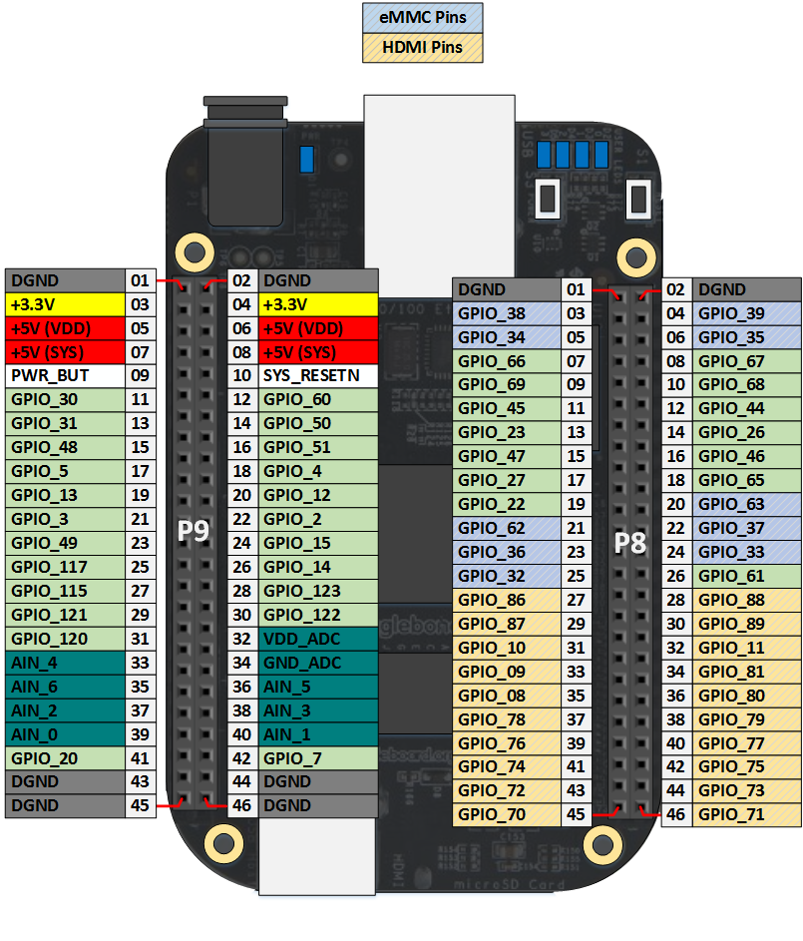
MODEL 3 : BCM2837

Raspberry Pi : 40 pin in that 27 GPIO,UART,I2C,SPI and 3.3 and 5v pins ...

